**MARKET RESEARCH ANALYSIS**

***CSIRO***

**Text Annotation Tool**

Presented By:

*Degala Anurag Yadav*

*Harsha Lakshmipuram*

*Amelia Wigg*

*Malayamarutham Sai Pradyumna*

*Sai Gautam Mandapati*

*Pavani Gujjarlapudi*

*Eswar Sai Krishna Gowra*

*Tharindh*u

Table of Contents

**OUR AIMS..........................................................................................................................3**

**OUR DELIVERABLES............................................................................................................3**

**TARGET MARKET................................................................................................................3**

**TARGET NEED......................................................................................................................**

**COMPETITOR ANALYSIS.......................................................................................................**

*Bioportal* **.............................................................................................................................**

*TagTog***.................................................................................................................................**

*LightTag***...............................................................................................................................**

*Monday***...............................................................................................................................**

*Asana***..................................................................................................................................**

*ZipBoard***..............................................................................................................................**

**FEASABILITY ANALYSIS........................................................................................................**

Market Research Analysis

OUR AIMS

To develop a web service that annotates text with definitions, taken from controlled online vocabulary services. Make it easier, simpler and more accurate to get a definition, which has been provided by a collaboration of online vocabulary services. A quick understanding which is enabled by hyperlinking technical terms to their corresponding definitions.

OUR DELIVERABLES

A tool to:

* Detect words or phrases with in a text that have definitions in one or more source vocabularies
* Allow the user to select which definition applies to the usage of the term in the context
* Allow the user to select an alternate or preferred term to replace the original
* Insert a hyperlink to the definition

TARGET MARKET

The target market of our tool includes anyone who is undertaking online research using the internet. There are no gender specifications of our target market, nor is there a specific age group due to the tool being aimed at anyone undertaking research. However, the target market must be old enough to be undertaking research.

* The web citizens doing research are the target market for the project.
* The web citizens can either be male or female and can be of any age group as there is no requirement of age or gender to be a researcher.
* The person’s income can be ignored as income doesn’t categorize the researcher.
* The text annotation is very helpful while reading the research papers.

MARKET NEED

**Description of the tool:**

Technical documents use the terminology of few specific words and phrases denote precise definitions of some concept. In most of the cases a single term has more than one meaning. By hyperlinking the text with accurate meaning, we can develop the understanding of a word or a meaning. This project will develop a tool and web micro service to enable semi-automated annotation of text with hyperlinks to definitions of terminology used in the research papers

**Need for this tool:**

In many of the research papers they are few typical words which have many other meanings for easy understanding. For this purpose this tool helps by clicking on the word by hyperlinking the text to website and find related meaning in that particular field.

**Demand of this tool:**

There are few types of tools in the market which helps in annotating words by providing various links. These tools have high demand because just to simplify the understanding of the people. In many research papers we can see lot of scientific terms which cannot be understood by people in general. With the help of this tool we are able to hyperlink those words and have different ontologies. So, there would be high demand for this tool in various fields.

COMPETITOR ANALYSIS

**Bioportal**

***Description of the tool***

Bio portal is the bio ontology website which helps in annotating the words by providing the various links for different websites where we can get the meanings for that words. In the website we can see the options such as ontologies library where we can find different libraries such as National cancer institute Thesaurus (NCIT).

So, from the below screenshot when we enter a text into the space and select the match longest only check box and select the National cancer institute of thesaurus as my ontology search library and click the tab “get annotation” so we can get the results.

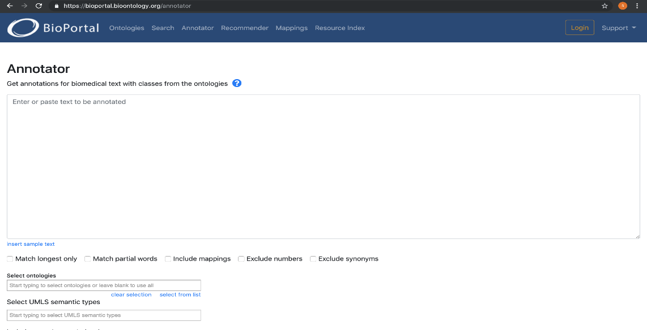

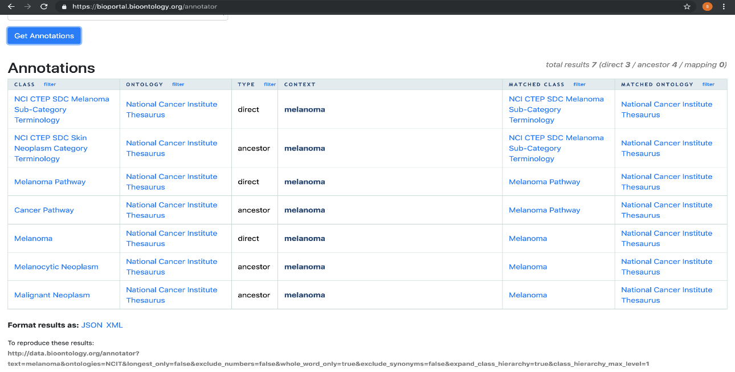

***Features of the tool***

1. The first feature this website provides is ontologies tab where we can get the different ontologies and we can submit new ontology for adding into the library and we can search based on the entry type, category, format, group.

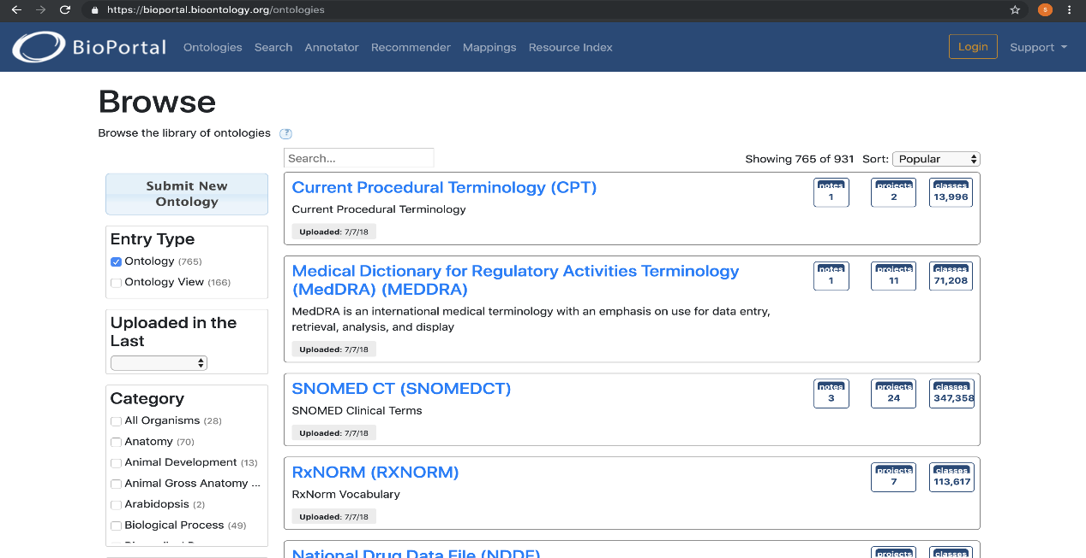

2. The second feature this website offers class search option when we enter certain medical terminology term, we can get the results based on its class and matches with the ontology libraries and gives the results.

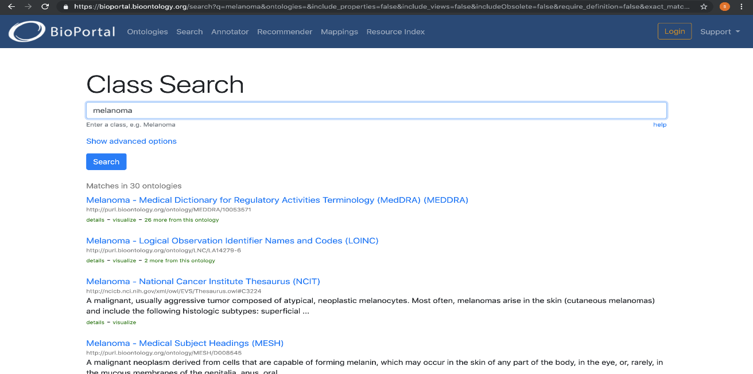

3.The next feature this website offer annotators options where we can get the different data from different annotators.

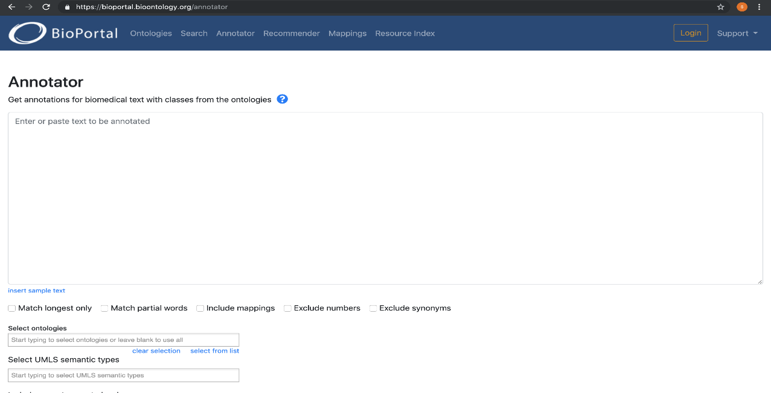

4. Recommender option is the next option where we can get the recommendations for ontologies based on the text we enter and there is an additional option of check boxes where we can select text or keywords and ontology or ontology sets and we can recommendations according to the input provided by the user.

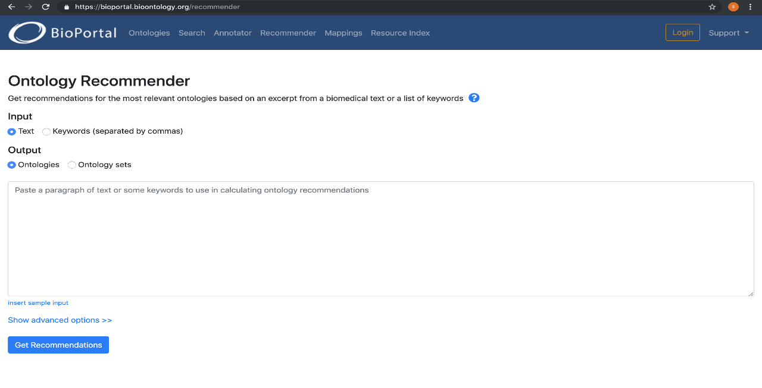

5.Mappings is the next feature which this website offers where we can map between different classes in different ontologies.

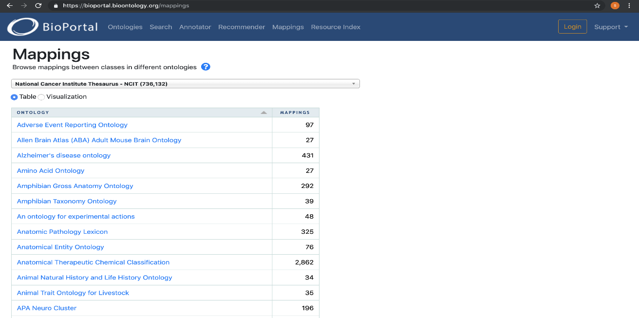

6. Resource index is the option where we can select data from various bio medical resources.

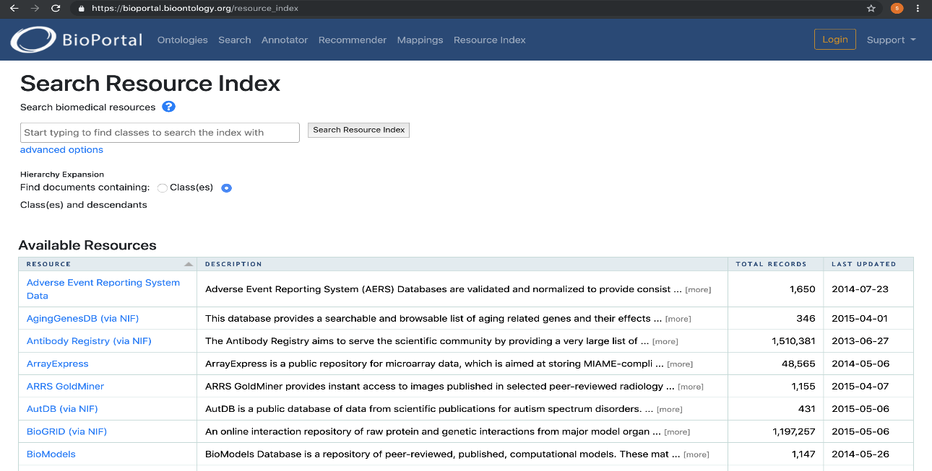

***Features that align with our aim***

The most important feature we will use for our aim and deliverables is the annotator so we will be creating an annotator where we will integrate two API from the existing ontology libraries and develop an annotator.

***Features that would need to be altered***

No features need to be added altered in return we will be developing a new website which can provide the meanings for the words which we type into the text space and search the meaning in the ontology library and retrieve the meaning for that word.

***Benefits of the Tool***

* Free web page annotation tool
* Advance search options available based on databases
* Customisation options according to user queries
* Easy to use and handle
* Get recommendations for the input query we provided

***Limitations of the Tool***

* We can search only ontology & biomedical bases keywords

***User Scenarios***

* The user needs to open the bio-portal browser and just search the annotated word.
* The user doesn’t need to login or signup for annotated words.

***Price***

Bio portal annotator is an open source, so anyone can be able to use that for free of cost. There is a login option where user can be able to create their account & download ontologies latest versions for their work.

**LightTag**

***Description of the tool***

Light Tag is a website which is helpful and used for annotating the words. It is a text annotation platform for data scientists creating AI training data. LightTag aims to solve one of the main bottlenecks of the deep learning-based AI development.

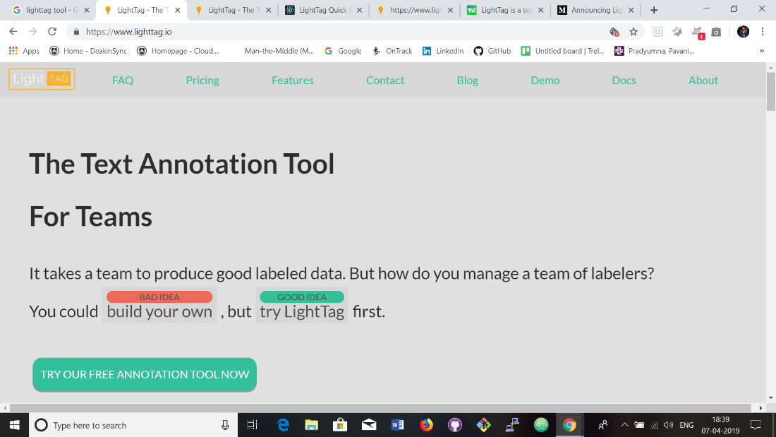

***Features of the tool***

It also employs its own “AI” to learn from previous labelling and make annotation suggestions. The platform also automates the work of managing a project, in terms of assigning tasks to labellers and making sure there is enough overlap and duplication to keep accuracy and consistency high. LightTag’s annotation interface is both beautiful and optimized to maximize annotator productivity while minimizing subtle biases that a UX can introduce. LightTag’s interface allows annotation with a mouse or keyboard. Keyboard shortcuts abound to make the annotators work fast and easy. It can annotate any language like English financial jargon, Chinese legalese, Arabic tweets or Hebrew medical records. LightTag allows you to define an annotation task and specify how many annotators you’d like to have annotating each example. LightTag will assign work to annotators as they arrive, making sure that you reach your annotation goals in the most efficient way possible.

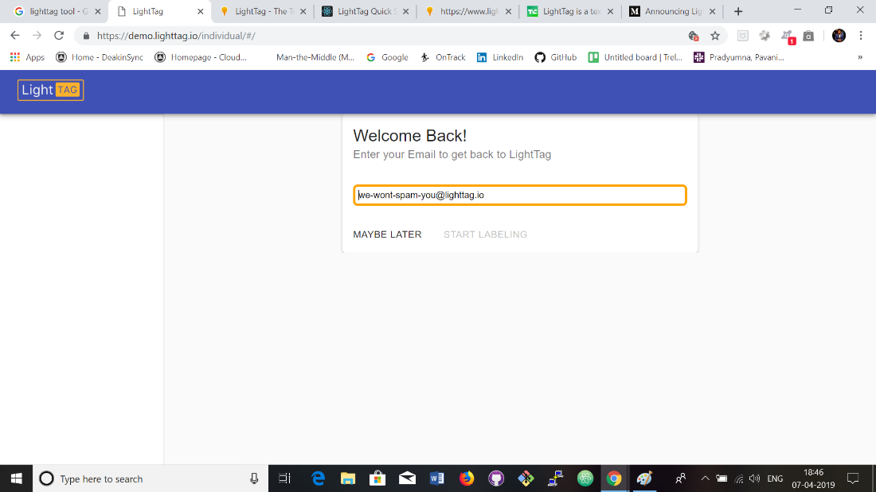

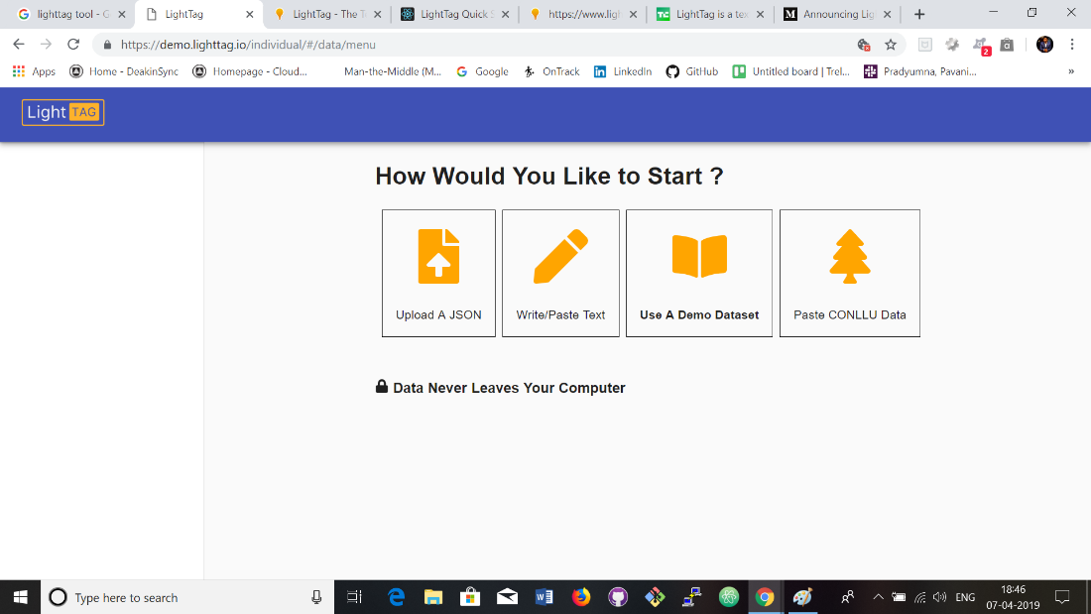

In the above image we can see four options “Upload a JSON”, “Write/ Paste Text”, “Use a Demo Dataset”, “Paste CONLLU Data”. LightTag expect you to upload your data as a JSON array of objects.



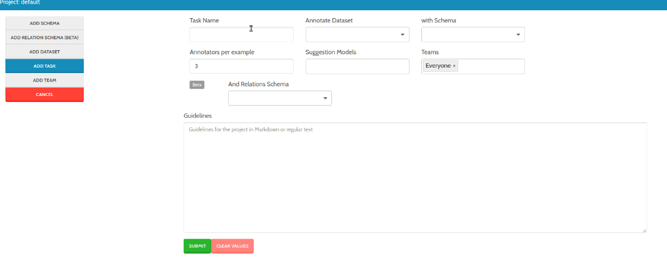

***Features that align with our aim***

Comparing with our project aim deliverables LightTag is completely different with what we are going to implement. In our project we will highlight the phrases and will provide the hyperlink there so that user can take or use the better alternative text/ phrases.

***Features that would need to be altered***

No features to be altered to align with our aim and deliverables.

***Benefits of the Tool (pros)***

* Can annotate in any language
* Measures inter annotator agreement to understand the quality of annotation
* Continuously boot straps the projects and provides suggestions
* Can add new meaning from our own library and upload it to LightTag with Rest API

***Limitations of the Tool (cons)***

* Provides hourly rate for engineers to build own labelling tools
* Comes with only in on-premise version

***User Scenarios***

* The user needs to sign in first to use the tool.
* The user can see various options like upload Json, write or paste text, use demo data base and paste conllu data.
* The user can choose any option regarding the project and annotate the words.

***Price***

It is free of cost so the user can just create an account and use. This tool can be downloaded and mainly helpful for team projects.

**TagTog**

TagTog is a Text Annotation Tool to Train AI. Mainly TagTog use for train text mining methods. Generally, there are two types of people use this tool,

1. People who want to have annotated and register part of the knowledge with in their organization.
2. People wo need want to train their own material models.

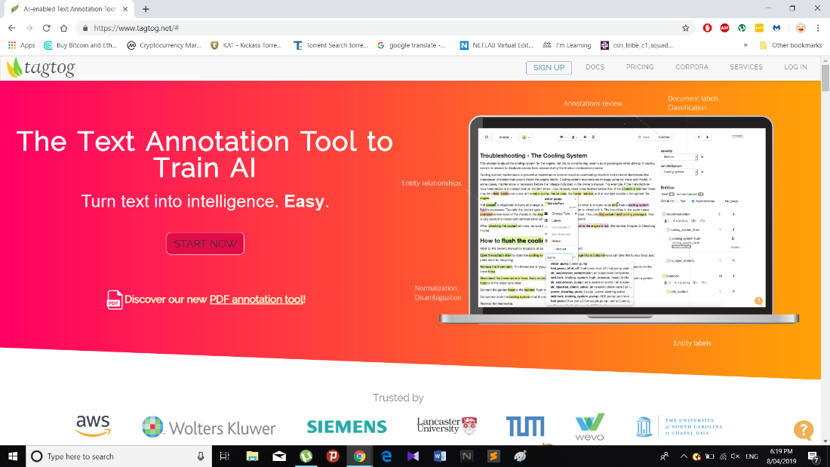

***Description of the tool***

Users can install TagTog for their computer or they can use website for start their works. Mainly TagTog is use for group works. Because, admin or owner has an option for invite others who can help to develop the project. This is most critical point for any kind of group workers.

Annotate of this tool is use as manually or automatically. It will eventually save the costs and time. Collaboration is also a massive space for succeed the project. Not only that, below options are the major part of TagTog,

* Index data or augment
* Find custom insights inn text automatically
* Classify text
* Train your own AI

Before, using the tool user should sign up.

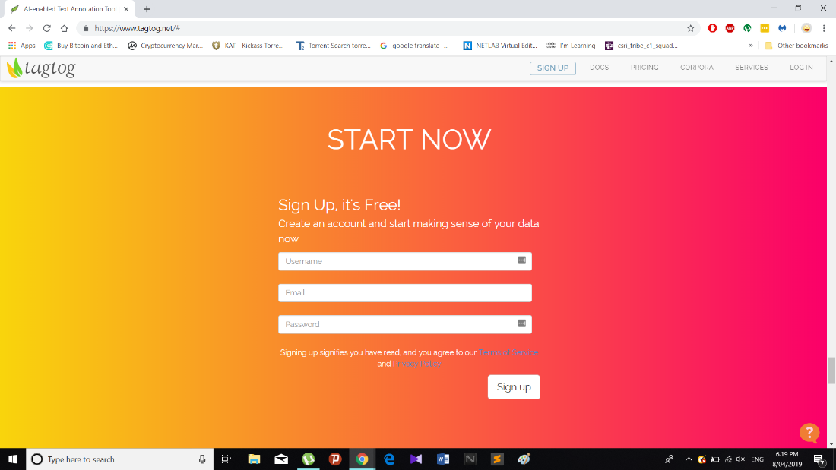

After that users have an option called “create a new project “

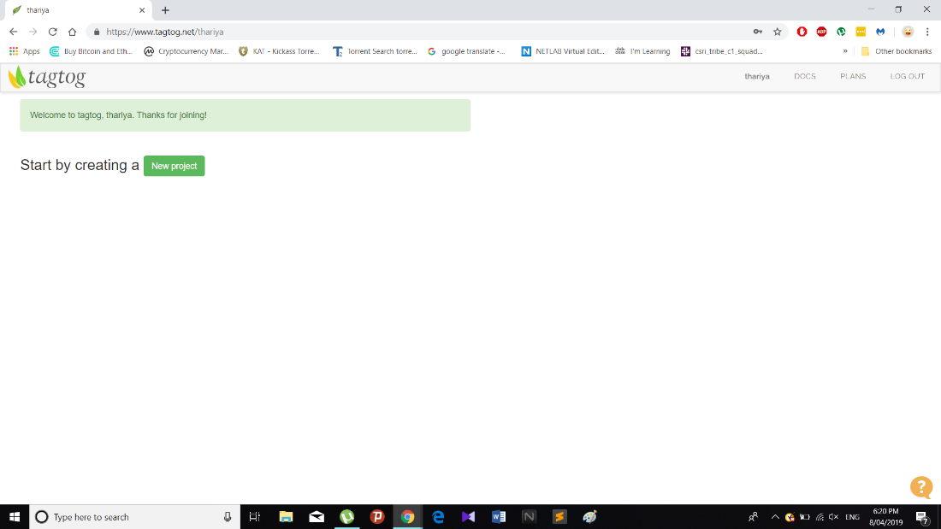

***Features of the tool***

**Adding a document to project**

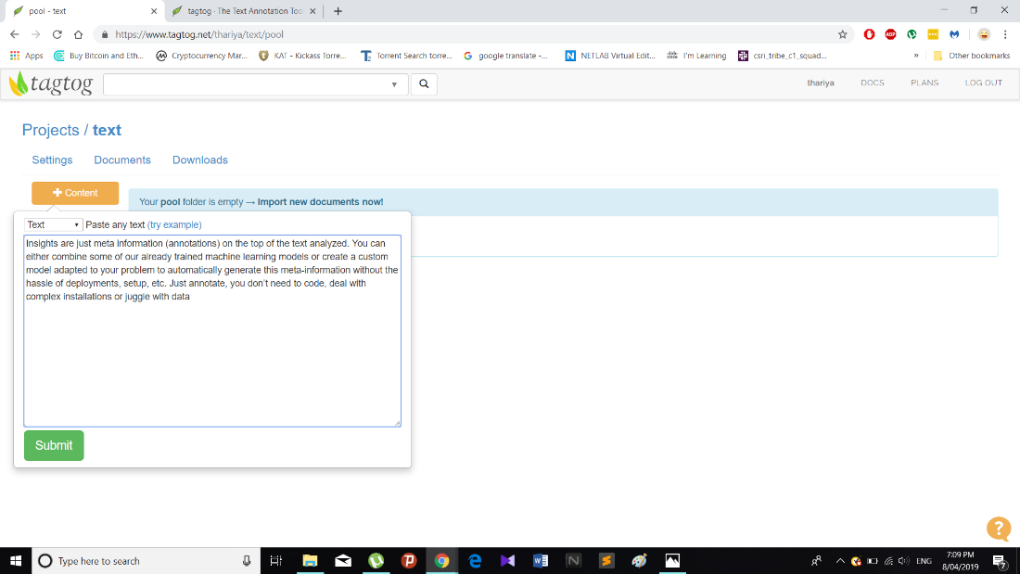

This stage is very critical because project owner or project admin to define what is exactly need for project. Not only that, TagTog has several functions such as Annotables, Entities, Dictionaries, Relations, Document Levels, Entity Labels, Webhooks, Annotations, Members and admin.

Most importantly members can edit any cording with the permission.

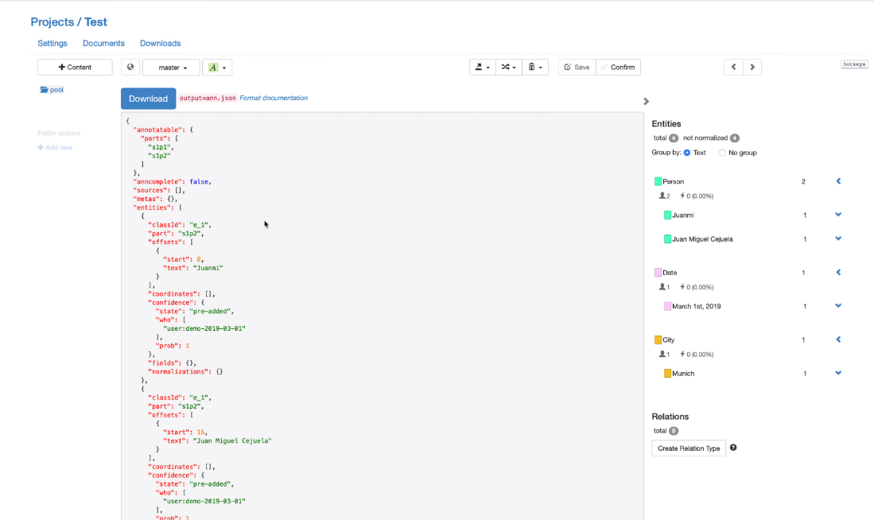

**Manual text annotation**

This tool is use for quickly annotate and normalize entities.

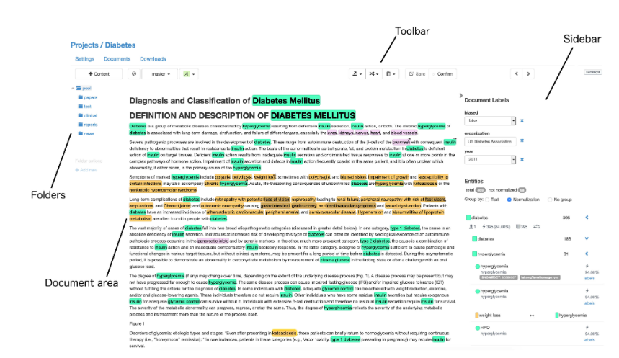

***Features that align with our aim***

**Manual text annotation :-**

* Many members can work as a team and work on same time.
* Can edit text on same time.

**Editing code :-**

* User can add or edit any code related to the project.

***Features that would need to be altered***

There are no any features that would need to be altered to align with our project aim and deliverables.

***Benefits of the Tool***

* Customization the options.
* Easy to use and handle.
* Can select different members.
* Has a good speed.

***Limitations of the Tool***

* Only leader can add or delete comment
* Need to log in every time.

***User Scenarios***

* The user needs to sign in and create the project first.
* The user can add the document to the project and annotate the text.
* The user can edit the code of the project.

*Price*

The tool of is freely available for anyone to use and can be downloaded for anyone.

**Monday**

***Description of the tool***

“Monday” is an open source tool that allows users to exchange their data and other information. Specially this tool is very helpful for team projects by assigning tasks and prioritizing according to the requirement. The data can be integrated to any tool and use at one place.

***Features of the tool***

“Monday” has many of useful tools some of them are as follows,

1. “About yourself” this option allows to describe about yourself.

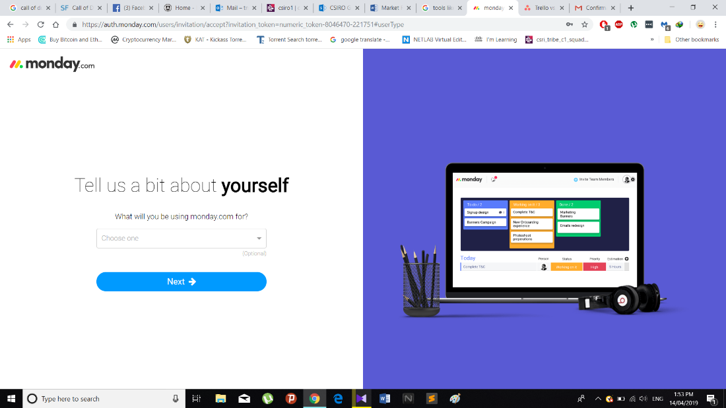

***2.” About team” this option allows to identify the team.***

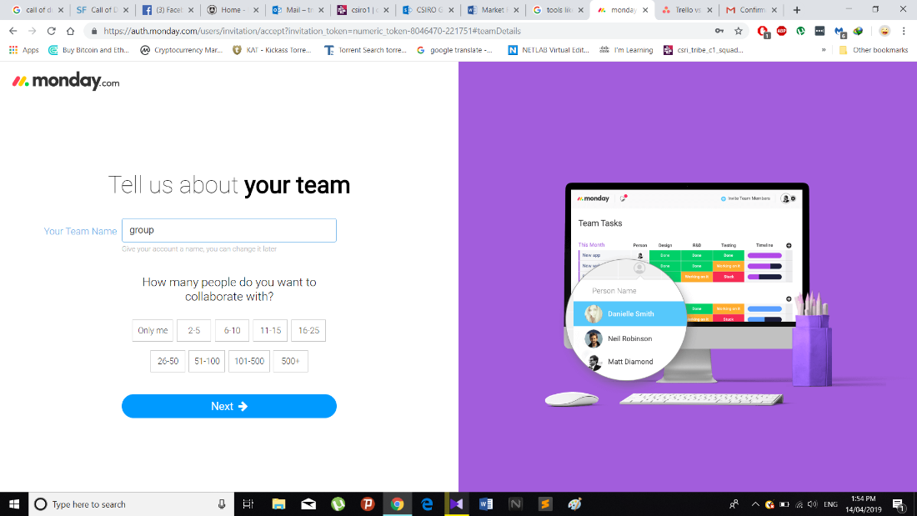

1. ***What kind of activity your team willing to do.***

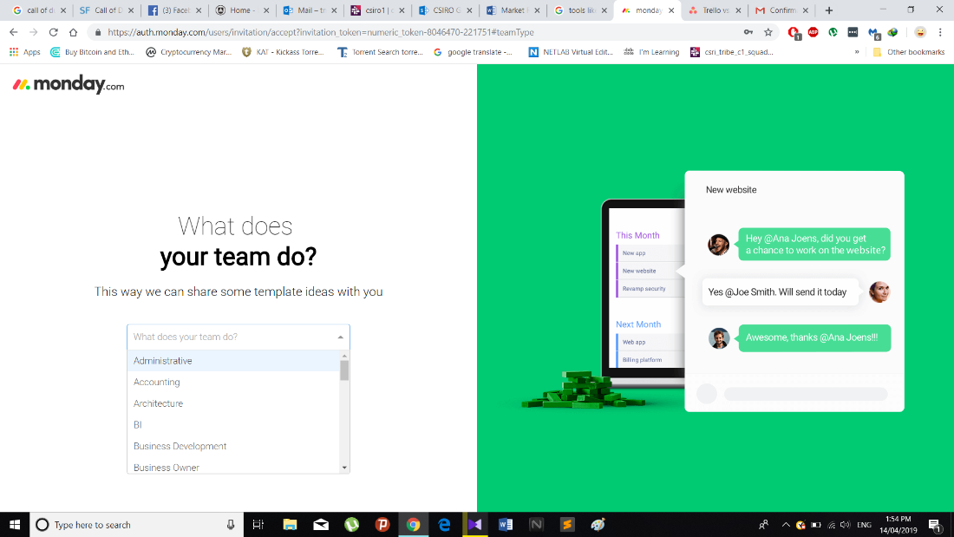

1. ***What kind of things your team want to mange?***

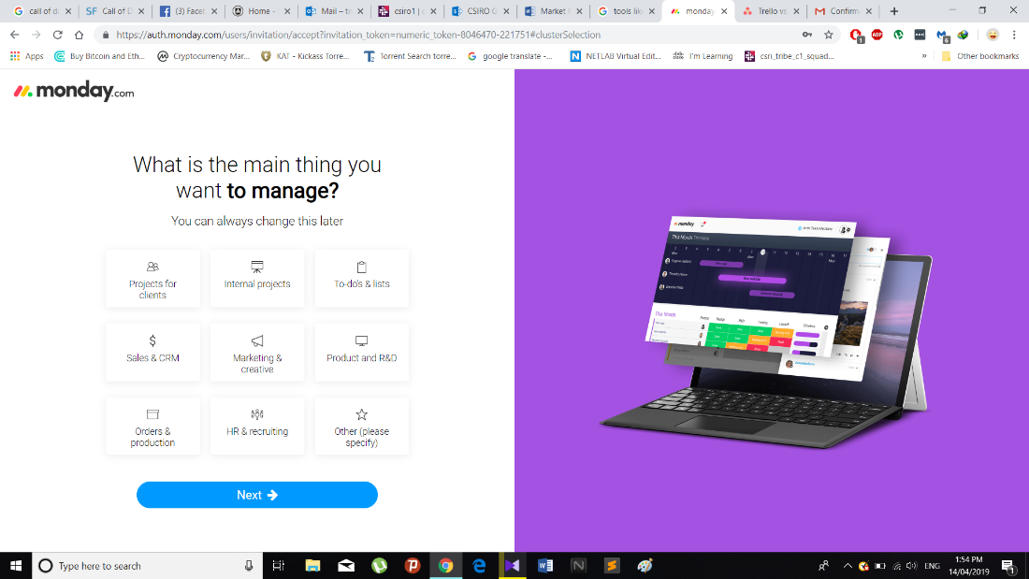

1. ***User also can create their own url for page.***

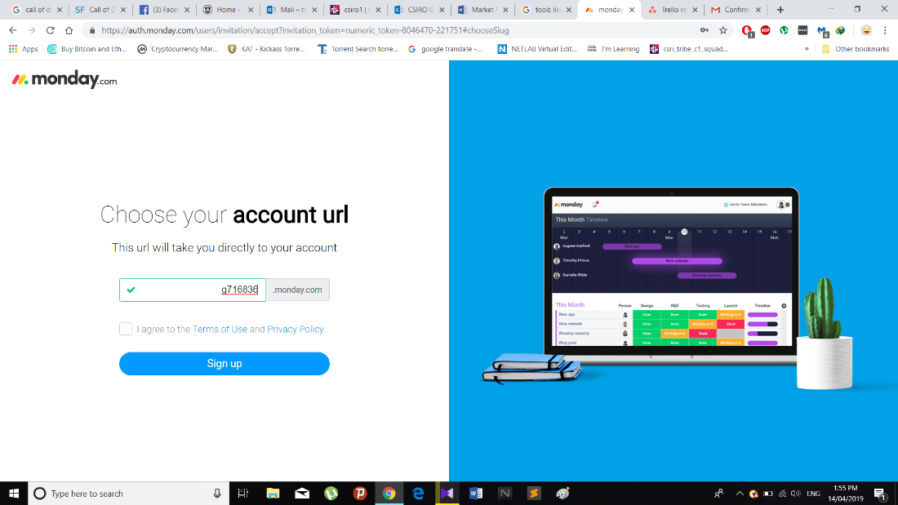

***Features that align with our aim***

**Able to select team members**

This tool is very helpful for group project like our project. We can select our team members directly from using their emails or usernames.

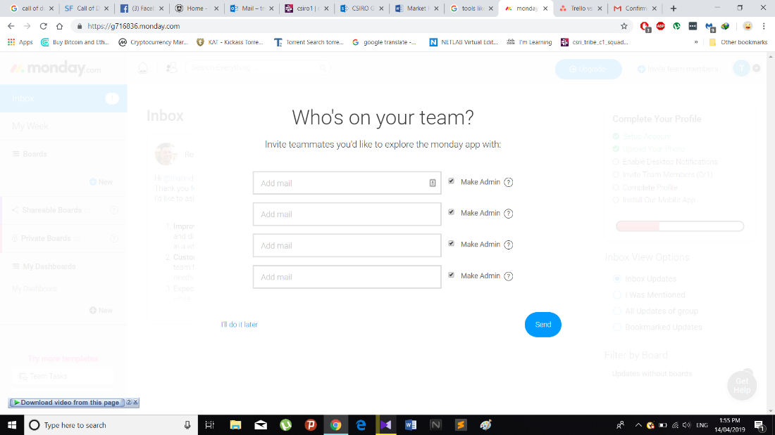

**Creating a plan**

Project plan is also a critical factor for continue the project. So that, having a proper project plan is main fact. This tool allows to create a project plan and project overview.

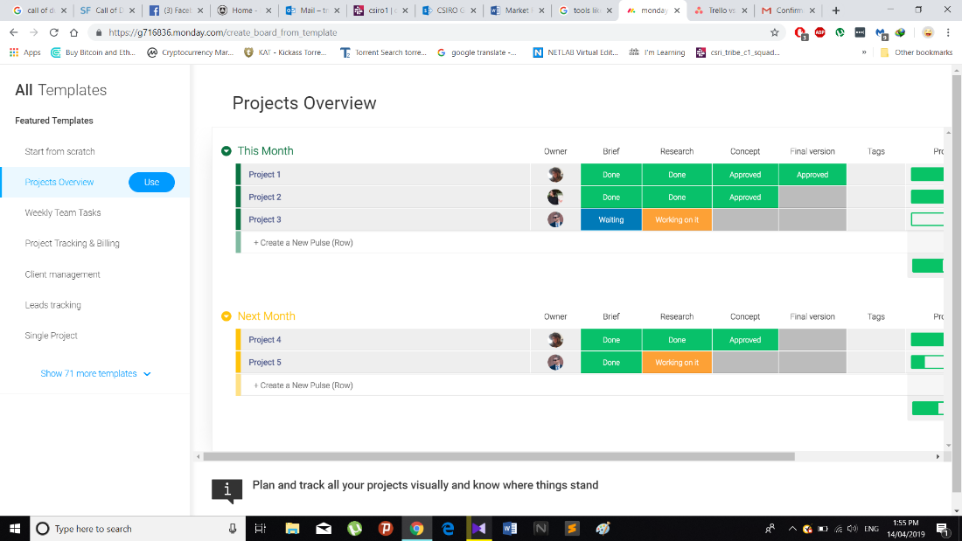

***Features that would need to be altered***

There are no any features that would need to be altered to align with our project aim and deliverables.

*Benefits of the Tool*

* Customization the options.
* Easy to use and handle.

*Limitations of the Tool*

* Users need to login to process
* It takes much more time to make a comment

*User Scenarios*

* *Usually this tool is using for project groups*
* *The user needs to sign in for annotation*
* *Then the user can create the project group, include team members and manage the tasks*

***Price***

The tool of is freely available for anyone to use and can be downloaded for anyone.

**Asana**

***Description of the tool***

Asana is the easiest way for teams to know who's doing what by when. Mainly Asana use for web and mobile application development.

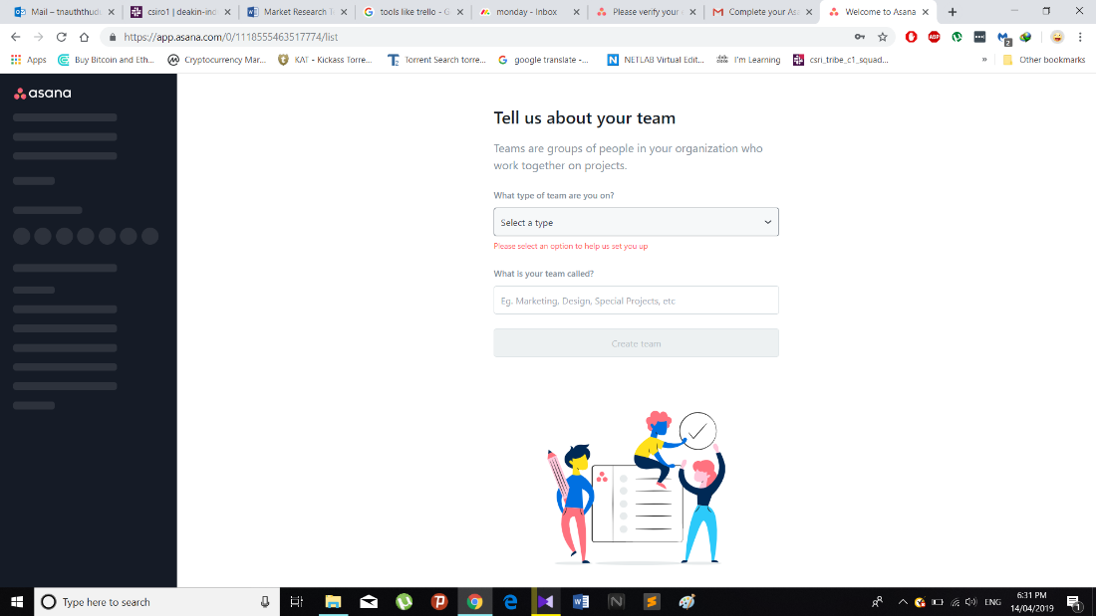

***Features of the tool***

Aasana has many of features for developing stage. As an example, each and every members of group can edit and add codes.

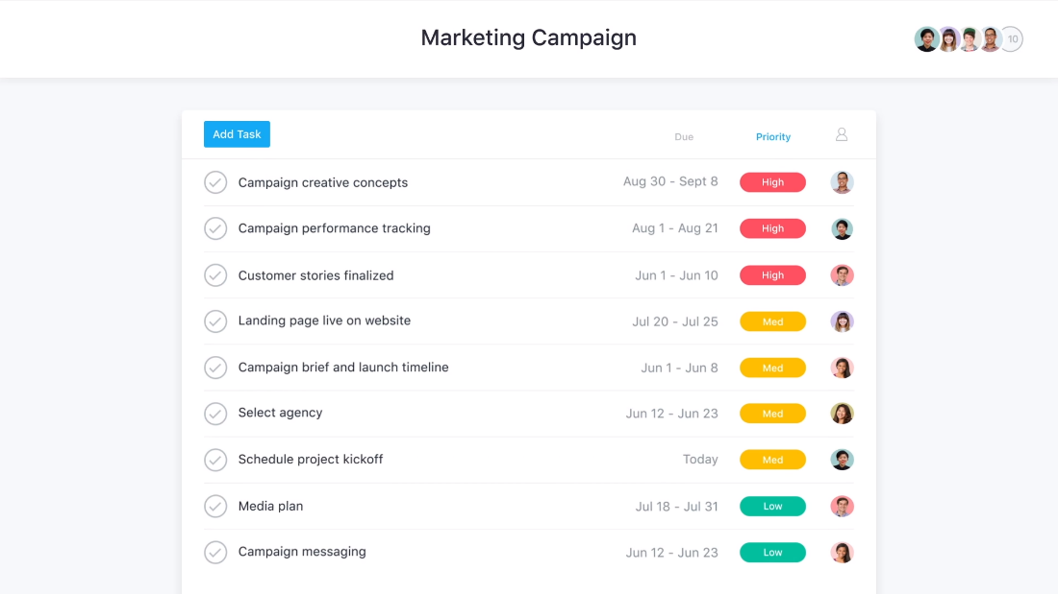

***Features that align with our aim***

**Can easily divide work load**

This tool is very helpful for divide work load for each team members. Not only that, sprint plan is very helpful for creating subtask.

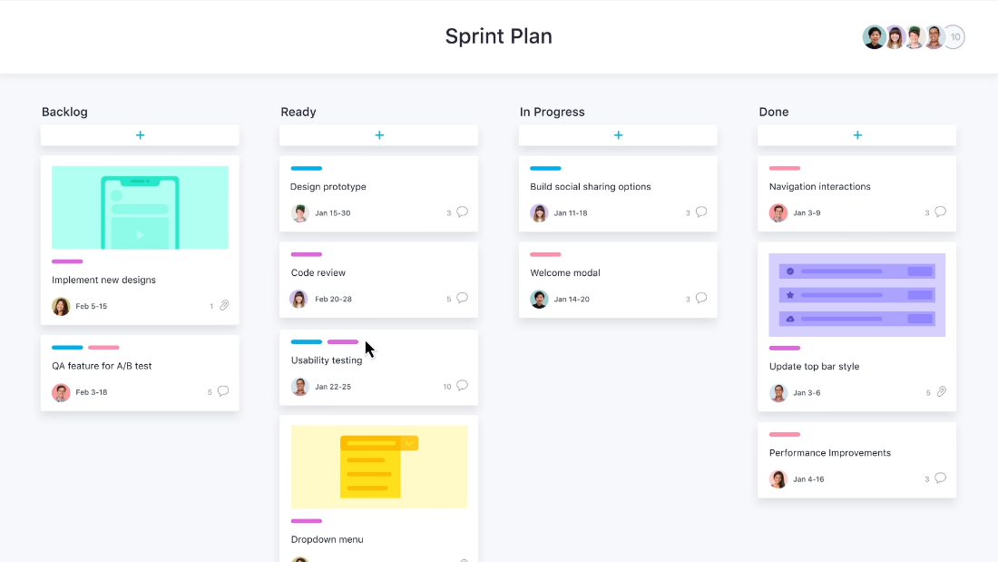

***Features that would need to be altered***

There are no any features that would need to be altered to align with our project aim and deliverables.

***Benefits of the Tool***

* The tool is excellent for group collaboration
* The tool has many features that assist development

***Limitations of the Tool***

* This tool has only one-month trail.
* User need to log in.

*User Scenarios*

* User doesn’t need to sign in for using the tool
* Any member in the team can edit and code the project
* The user can easily divide the work load.

*Price*

First month free and after first month the price is $129 for full pack.

**Diigo**

***Description of the tool***

It is one of the most commonly used tool for web annotation which let you bookmark and tag web pages. In addition to it we would also be able to highlight a part of a webpage if you wish to emphasize something and attach sticky notes to it.

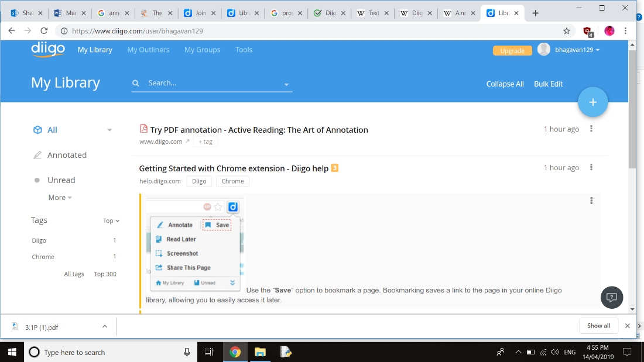

***Features of the tool***

* In this the advanced search allows you to rummage through the text of pages you have bookmarked which includes tags, titles, URLs and even your own comment and highlights
* One of the best features of Diigo is your ability to comment on other users’ notes which can be set to either public or private

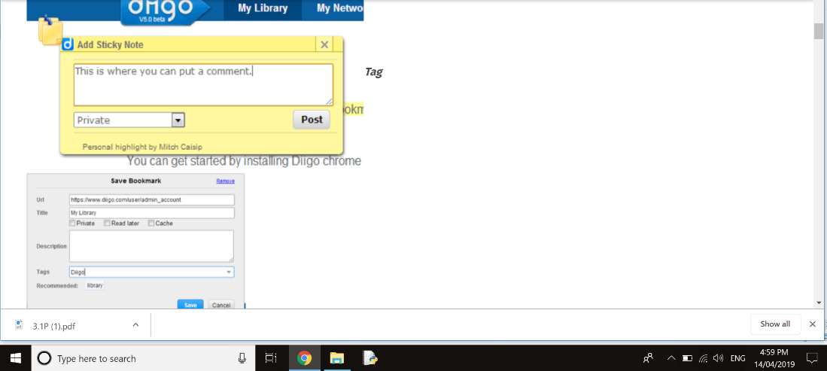

***Features that align with our aim and deliverables***

* Comparatively with our project this is bit different in our project we highlight words and provide a hyper link for them whereas in this we highlight webpages and can share any information.

***Features that would need to be altered to align with our aim and deliverables***

* There are no features that are need to be altered with our project.

***Benefits of the Tool***

* Customization options in this tool and social feature help students learn key web skills like curating and sharing online content.
* Easy to install extension and start knowledge from around the internet it is a great capturing tool.
* The features it offers to collect articles and text snaps from the web and pdf are quite nice and can be really useful.

***Limitations of the Tool***

* In this the user need to be logged into Diigo and stay within one browser tab to use the system. And there isn’t much guidance on selecting sources.
* The premium versions are a bit pricy.
* As a free user you are given limited usage of the software including a limit on how many words you can highlight and bookmarks. If it is a tool that is used very often, it is worth spending.

***User Scenarios***

* The user needs to open the Diigo website first.
* Then can search for the annotated words.
* The user can highlight the words or paragraph in the web page.
* The user is able to comment on the other users notes which is set for public or private.

***Price***

* Diigo membership varies in three ranges standard, professional, business. These are applicable for the members in Diigo. The price varies according to the ranges.

**ZipBoard**

***Description of the tool***

ZipBoard is a bug tracking tool which allows to take screenshots, annotate and collaborate the web pages. It also assigns tasks while browsing their web-based products.

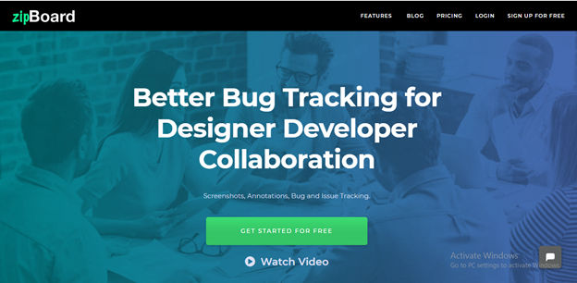

***Features of the tool***

Zipboard has many features which includes annotation and collaboration as well. The main features are as follows:

1. “Create new project” needs to create a project first for the annotation. Then we can annotate and tracks the progress.

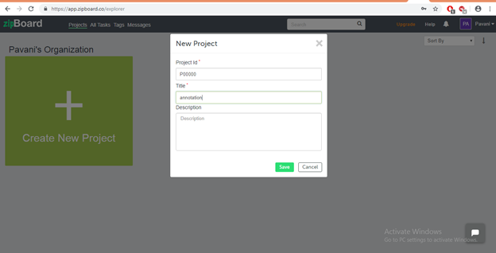

1. Not only annotation it helps in tracking the progress to stay on top of the projects and gets the work done.

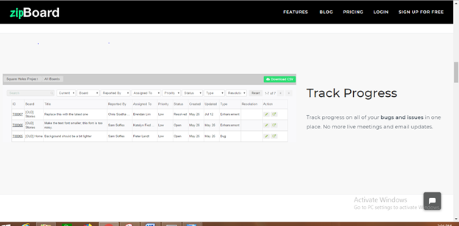

3. Unlimited collaborations: no limit on collaborations that can be added to the project.

4. Annotate the words in the screen, can comment and assigns tasks on these screens.

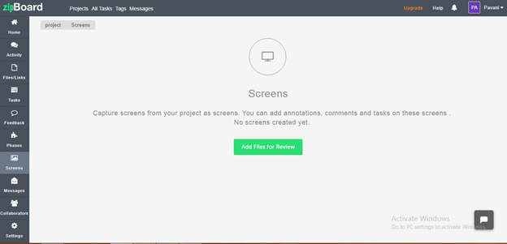

***Features that align with our aim***

Our project highlights the words that are annotated and provides hyperlink whereas in this we can annotate the words from the web pages in screens and can provide meanings by ourselves.

***Features that would need to be altered***

There are no features that need to be altered to align with the aim and deliverables of the project.

***Benefits of the Tool***

* Free web page and image annotation tool
* Helps in collaborative working
* Can annotate the words by ourselves.

***Limitations of the Tool***

* *Only free signup for one project.*
* *Add on costs.*
* *No offline access*

***User Scenarios***

* The user has to create account in ZipBoard.
* Then the user needs to create the project for annotation.
* Later the user can annotate the words or images.

***Price***

The first project is free and then a monthly subscription is required for$39per month. The same concept applies for the team version, however the monthly is cost $79.

FEASABILITY ANALYSIS

Based on initial understanding of the basic requirements of the tool that is to be developed and the research undertaken into other relevant tools, it appears that the development of analytical text tool is feasible. However, as shown above in the document there are a range of similar tools that meet many of the requirements of the tool, which could be used instead of committing to the cost of developing a new similar tool. There are however many benefits of developing a new tool from scratch in order to ensure that all the requirements are met and all the features align with the tools purpose. A cost/benefit analysis would be a good step in determining the certainty of a financial payoff, however simply based of the information available at this point in time, a new tool could be foundationally modelled off the most similar existing tool and adjusted and developed to Superseed the original and meet all requirements. This conclusion however is based solely off the information provided and independent research and therefore cannot take into consideration the availability and longevity of finances.

REFERNECES

**References for TagTog**

Docs.tagtog.net. (2019). *tagtog · The Text Annotation Tool to Train AI*. [online] Available at: http://docs.tagtog.net/ [Accessed 8 Apr. 2019].

**Reference for Asana**

Asana. (2019). *Use Asana to manage your team's work, projects, & tasks online · Asana*. [online] Available at: https://asana.com/?noredirect [Accessed 14 Apr. 2019].

*Reference for monday.com*

G716836.monday.com. (2019). *monday.com: Your team's growth made easy | Sign In*. [online] Available at: https://g716836.monday.com/create_board_from_template [Accessed 14 Apr. 2019].

Reference for ZipBoard.com

Free website annotation tool for web developers, designers | zipBoard. (2019). Available at: <https://zipboard.co/?[Accessed15Apr.2019>].

**Refernce for Diigo**

*Social Annotations, Highlighting and Social Bookmarking*, retrieved 4 July 2006,

<https://www.diigo.com>